September 14, 2014

Smoke from Happy Camp and July Complex Fires Impacts Air Quality in Oregon and California
An area of smoke from the Happy Camp and July complex fires in northwest California was seen drifting to the north and east across northern California, Oregon,Idaho and Wyoming. Southwesterly winds increase over the region impacting the Ft. Jones, Yreka, and Klamath River communities, upstream of Happy Camp fires. The National Weather Service has issued a RED FLAG WARNING for the state of Oregon as a surface thermal trough will remain near the Oregon coast range and southwest Washington lowlands through Tuesday. The extremely low humidity, combined with the hot and breezy winds make conditions favorable for the development of new wildfires or the spread of existing ones. The smoke is the source of the high AOD values in today's MODIS Aqua retrievals.
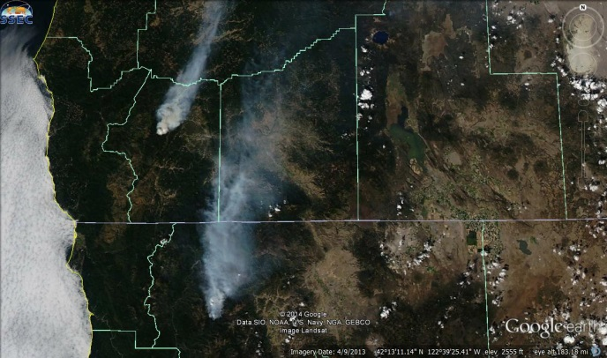 | 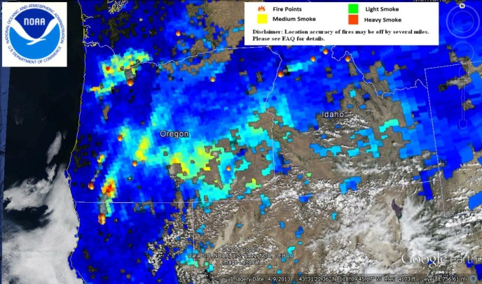
The air quality over this region was affected by the presence of smoke from these wildfires. Today's PM2.5 concentrations in Oregon and northern California reached Code Red AQI levels (Unhealthy), as shown in the Airnow.gov AQI animation.

